Chemistry

Unit 4

Area of Study 7 test:

Biochemistry

This sample test paper has been prepared as part of the Pearson suite of resources for the Year 12, Unit 4, ATAR Chemistry Course prescribed by the Western Australian School Curriculum and   
Standards Authority.

**Time** allowed

Reading time: 5 minutes Working time: 45 minutes

Materials required

An approved non-programmable calculator.

Chemistry Data Booklet. This may be downloaded from the SCSA website.

Structure of this paper

|  |  |  |  |  |  |
| --- | --- | --- | --- | --- | --- |
| Section | Number of questions available | Number of questions to be answered | Suggested working time (minutes) | Marks available | Percentage of total test |
| Section 1:  Multiple choice | 6 | 6 | 11 | 12 | 25 |
| Section 2:  Short answer | 3 | 3 | 14 | 15 | 31 |
| Section 3: Extended answer | 2 | 2 | 20 | 21 | 44 |
| Total | | | 45 | 48 | 100 |

Section 1: Multiple choice 25% (12 marks)

This section has 6 questions. Answer all questions by circling the correct option. Marks will not be deducted for incorrect answers. No marks will be given if more than one answer is completed for any question.

Suggested working time: 11 minutes

____________________________________________________________________________________

1 The secondary structure of many proteins includes helical regions. The type of chemical bond responsible for maintaining this shape is:

A hydrogen bonds.

B ion–dipole bonds.

C ionic bonds.

D covalent bonds.

2 Which of the following statements is true?

A Leucine, isoleucine and methionine all have non-polar side chains.

B Serine, threonine and proline all have side chains that can form hydrogen bonds with each other.

C Tyrosine and tryptophan contain delocalised electrons.

D Lysine, asparagine and alanine all have basic amino acids.

3 When a protein such as insulin is formed, the condensation reaction that occurs involves:

A a carboxyl functional group and an amino functional group.

B two hydroxyl functional groups.

C a hydroxyl functional group and a carboxyl functional group.

D a hydroxyl functional group and an amino functional group.

4 Which of the following bonds/interactions are responsible for the secondary structures of proteins?

A the intermolecular forces between side chains of amino acids, including ion–dipole, dispersion forces, dipole–dipole attractions and hydrogen bonds

B the non-covalent interactions between the different polypeptide subunits that make up a multi-unit protein complex

C the hydrogen bonds between the amide C=O and N–H on the peptide backbone

D the C–N peptide bonds between adjacent amino acids in a polypeptide chain

5 What will be the molar mass of a tripeptide formed from the condensation of the amino acids phenylalanine (M = 165 g mol−1), isoleucine (M = 131 g mol−1) and methionine (M = 149 g mol−1)?

A 391 g mol−1

B 409 g mol−1

C 445 g mol−1

D It will depend on the sequence in which they are connected.

6 Which of the following statements is false?

A Enzyme activity can be affected by both pH and temperature.

B Enzymes act as catalysts and speed up the rate of reactions in biological systems.

C An enzyme is said to be denatured when its primary structure is disrupted.

D The tertiary structure of an enzyme is critical to its catalytic function.

End of section 1

Section 2: Short answer 31% (15 marks)

This section has 3 questions. Answer all questions. Write your answers in the space provided.

When calculating numerical answers, show your working or reasoning clearly. Express numerical answers to the appropriate number of significant figures and include appropriate units where applicable.

Do not use abbreviations, such as ‘nr’ for ‘no reaction’, without first defining them.

Suggested working time: 14 minutes

____________________________________________________________________________________

Question 7 (7 marks)

Enkephalins are short polypeptides involved in the nervous system’s detection of pain and harm. The structure of met-enkephalin, so called because it contains a methionine residue, is shown below.

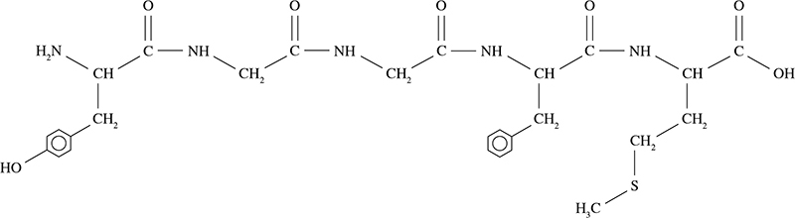

a Using the three-letter abbreviations for each amino acid, write the structure of  
 met-enkephalin. (3 marks)

___________________________________________________________________________

b On the structure above, circle and label one each of the following.

W peptide bond

X terminal carboxy group

Y terminal amino group

Z benzene ring (4 marks)

Question 8 (4 marks)

Aspartame is an artificial sweetener also known as Equal or Splenda. It was discovered by accident in 1965 by a scientist who wanted to synthesise a tetrapeptide for another purpose when he licked his finger to pick up a piece of paper. It is a methyl ester of the dipeptide Asp–Phe.

a Draw the structure of the dipeptide Asp–Phe as it would exist under strongly acidic   
conditions. (2 marks)

b Aspartame is formed when methanol is reacted with the dipeptide Asp–Phe under acidic conditions. It is a monoester, not a diester. Using this information, draw the two possible structures for aspartame in the space below. (2 marks)

Structure 1

Structure 2

Question 9 (4 marks)

Enzymes are increasingly being used in industry to catalyse reactions. Give two advantages and two disadvantages of using an enzyme (biological catalyst), instead of an inorganic catalyst.

_______________________________________________________________________________

_______________________________________________________________________________

_______________________________________________________________________________

_______________________________________________________________________________

_______________________________________________________________________________

_______________________________________________________________________________

_______________________________________________________________________________

**End of section 2**

Section 3: Extended answer 44% (21 marks)

This section has 2 questions. Answer both questions. Write your answers in the space provided.

When calculating numerical answers, show your working or reasoning clearly. Express numerical answers to the appropriate number of significant figures and include appropriate units where applicable.

Do not use abbreviations, such as ‘nr’ for ‘no reaction’, without first defining them.

Suggested working time: 20 minutes

____________________________________________________________________________________

Question 10 (7 marks)

Below is a section of a protein showing two parallel strands of the same polypeptide chain. The side chains of each amino acid are abbreviated, using their three-letter abbreviation.

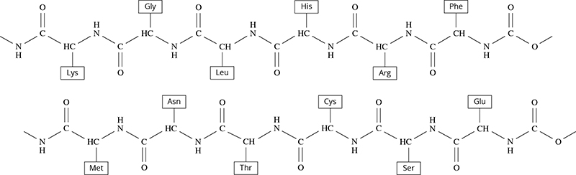

a The secondary structure of a protein includes β-pleated sheets and α-helices. Draw one of the bonds responsible for these secondary structures on the diagram above. Label it with the   
letter B. (1 mark)

b Asparagine (Asn) and lysine (Lys) are two amino acids in close proximity in the protein structure above. Their structures are shown in full below.

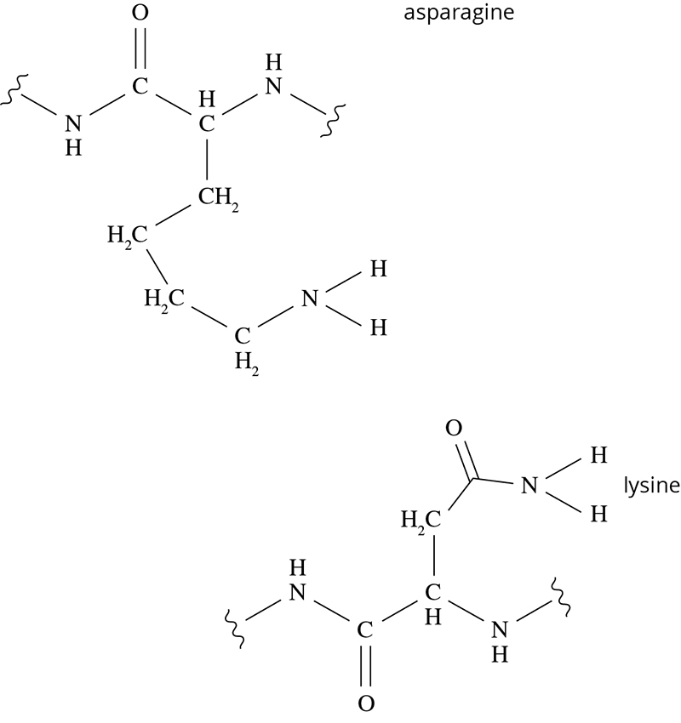

i What type of intermolecular force is responsible for the attraction between these two amino acids? (1 mark)

______________________________________________________________________

ii Label this interaction on the diagram above. (1 mark)

c When the pH of a protein’s environment is lowered, the tertiary structure can become altered and loss of function can occur.

Describe how the tertiary structure of a protein can be altered at low pH values, with specific reference to the interaction between lysine and asparagine. (4 marks) ___________________________________________________________________________

___________________________________________________________________________

___________________________________________________________________________

___________________________________________________________________________

___________________________________________________________________________

___________________________________________________________________________

Question 11 (14 marks)

The production of ethanol is an important global industry with over 100 billion litres produced each year. Ethanol can be produced using two different methods; fermentation, using an enzyme catalysed pathway, and the hydration of ethene, using an inorganic catalyst.

a Write balanced equations to represent both processes, the hydration of ethene, and the fermentation of glucose (C6H12O6).

Hydration of ethene: (2 marks)

___________________________________________________________________________

Fermentation of glucose: (2 marks)

___________________________________________________________________________

b The hydration of ethene is an exothermic process with ΔH = –45 kJ mol–1. The reaction is conducted at temperatures of 270–300°C and at a relatively high pressure of 6000–7000 kPa. With reference to rate and yield, account for the choice of these conditions. (6 marks)

___________________________________________________________________________

___________________________________________________________________________

___________________________________________________________________________

___________________________________________________________________________

___________________________________________________________________________

___________________________________________________________________________

___________________________________________________________________________

___________________________________________________________________________

___________________________________________________________________________

___________________________________________________________________________

___________________________________________________________________________

___________________________________________________________________________

___________________________________________________________________________

___________________________________________________________________________

___________________________________________________________________________

___________________________________________________________________________

c By contrast, the fermentation of glucose only takes place within a narrow pH range. Explain why the fermentation of glucose could not be carried out at the same high temperatures as the hydration of ethene, nor at low temperatures. (4 marks)

___________________________________________________________________________

___________________________________________________________________________

___________________________________________________________________________

___________________________________________________________________________

___________________________________________________________________________

___________________________________________________________________________

___________________________________________________________________________

End of questions